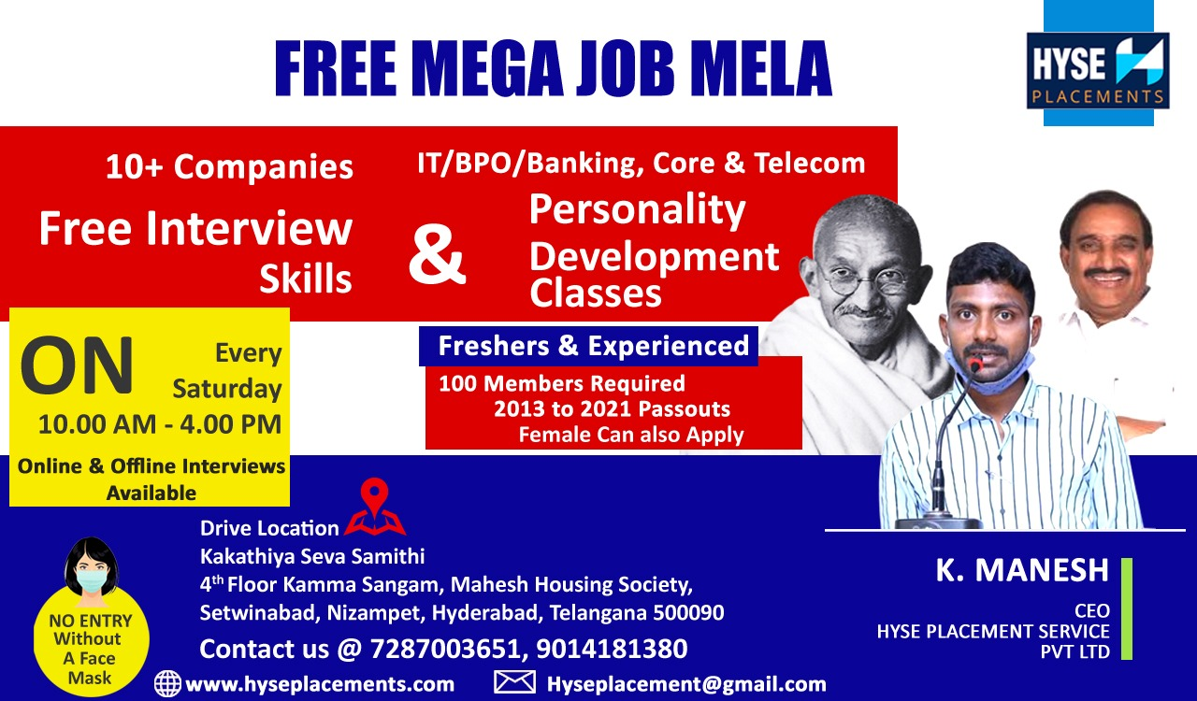

**HYSE Placements & Digital Academy**

**www.hyseplacements.com**

**www.hysedigitalacademy.guru**

**(All the below services are Free)**

**We Provide Training on 8 Domains’**

**(Java, UI+UX, Data Science+ Python+ AI+ ML, Testing, Digital Marketing, Content Writing, Spoken English + MS Office+ MS Excel + Communication Skills, Interview Preparation + Personality Development)**

|  |  |  |  |
| --- | --- | --- | --- |
| **Course Details** | | | |
| **Course** | **Timings** | | **Course Duration** |
| **Morning Batch** | **Evening Batch** | **3 Months** |
| **DATA SCIENCE** | **7.00 AM to 8.00 AM** | **7.00 Pm to 8.00 PM** |
| **JAVA** | **7.00 AM to 8:30 AM** | **7:00 PM to 8:30 PM** |
| **UI&UX** | **8.00 Am to 9.00 Am** | **8.00 PM to 9.00 PM** |
| **TESTING** | **8:30 AM to 10:00 AM** | **8:30PM to 10:00 PM** |
| **DIGITAL MARKETING** | **9:00 AM to 10:30AM** | **6:00PM to 7:30PM** |
| **CONTENT WRITING** | **-----** | **8:00 PM to 9:00PM** |
| **Ms Excel**  **+**  **Ms office**  **+**  **Communication Skills**  **+**  **Spoken English** | **9:00 AM to 10:00 AM** | **5.00 PM to 6.00 PM** |
| **Interview skills, Resume Making**  **&**  **Personality Development** | **-----** | **For IT Students**  **3.00 PM to 4.00 PM**  **-------**  **For Non IT Students**  **4.00 PM to 5.00 PM** |

**We Provide**

* **Training + Internship + Working live Project + Internship + certification + Job Assistance.**
* **We Provide Every Month Free Training For 600 Students on Different IT Domains**
* **We Provide Top 6 Companies Interviews on 3rd Month of Training period.**
* **Rules and Criteria To join our Academy**
* **Should Have 50% In last Academic year**
* **Should have minimum 70+% To receive placement assistance or certificate**

**Important Note**

**We are providing Part time work for our Training Students where they can earn 5000Rs to 10000Rs per Month by working 1Hour on Online**

**Data Science using Python**

**Contents**

### Module I: Introduction to Python: History of Python, Features of Python, Environment set-up and Setting up path, Working with Python Basic Syntax, Variable and Data Types, Operators in Python, Conditional Statements(If ,If- else ,Nested if-else), Looping( for, While Nested loops), Control Statements(Break , Continue ,Pass)

### Module II: Functions, String Manipulation, Lists, Tuple and Dictionaries

### Functions

### Defining a Function, Calling a Function, Types of Functions, Function arguments,

### Anonymous Functions, Global and Local Variables

### String Manipulation

### Accessing Strings, Basic Operations, String slices, Function and Methods

### Lists

### Accessing list, Operations, working with lists Function and Methods

### Tuple

### Accessing tuples, Operations , working with tuples

### Dictionaries

### Accessing Values in Dictionaries and Working with dictionaries

### Module III: Modules and Exception Handling in python

### Modules: Importing module, Math module, Random module and Packages

### Exception Handling: Exception, Exception Handling, Except clause, Try clause, Finally clause, User Defined Exceptions

### Module IV: Advance Python :Object Oriented concepts in python, Data Abstraction, Data Encapsulation, Inheritance, Polymorphism

### Module V: GUI based programming: Tkinter Programming, Tkinter Widgets, Button, Creating GUI Using class Label, Geometry managers: Pack (), Place (), Grid (), Entry methods and Checkbutton

### Module VI: Working with Python NumPy

### Arrays : Creation of Array, Operations on Array, Array indexing and slicing, Array manipulations, Array with functions

### Matrix: [Creation](https://www.guru99.com/python-matrix.html#1) of Python Matrix, [Create Python Matrix using a nested list data type](https://www.guru99.com/python-matrix.html#3), [To read data inside Python Matrix using a list](https://www.guru99.com/python-matrix.html#4),[Adding Matrices Using Nested List](https://www.guru99.com/python-matrix.html#7), [Multiplication of Matrices using Nested List](https://www.guru99.com/python-matrix.html#8), [Create Python Matrix using Arrays from Python Numpy package](https://www.guru99.com/python-matrix.html#9), [Matrix Operation using Numpy.Array()](https://www.guru99.com/python-matrix.html#10), [Accessing NumPy Matrix](https://www.guru99.com/python-matrix.html#11)

### Module VII: Visualisation using Python

### [Matplotlib](https://matplotlib.org/), [Seaborn](https://seaborn.pydata.org/) ,[ggplot](http://ggplot.yhathq.com/),[Plotly](https://plot.ly/python/)

### Module VIII: [Python SciPy](https://www.journaldev.com/18106/python-scipy-tutorial#python-scipy)

### Use of Scipy, Install Scipy Library, Importing Scipy Library, Interacting with Numpy

### Module IX: Working with Pandas (Machine Learning)

### Series, Data Frames, Read CSV files, Read JSON files

### Analysis of data with Pandas

|  |
| --- |
| **“Thank you, Looking forward to Hear from You.”** |
|

### Module X: Case study of Data Science Problem using Python